St Brides Major CW Primary School



School Admission Form

**CHILD’S DETAILS**

|  |  |
| --- | --- |
| Child’s Surname |  |
| Child’s Forename |  |
| Child’s other Names |  |
| Child’s Gender |  |
| Child’s Date of Birth |  |
| Child’s place of residence. | Postcode : |

**APPLICANT’S DETAILS**

|  |  |  |  |
| --- | --- | --- | --- |
| Applicant’s Surname |  | | |
| Applicant’s Forename |  | | |
| Applicant’s other Names |  | | |
| Applicant’s Gender |  | | |
| Applicant’s place of residence. | Postcode : | | |
| Applicant’s phone number | Home | Mobile | Work |
| Applicants email address |  | | |
| Applicant’s relationship to the child |  | | |
| Do you have parental responsibility for this child? | | | Yes / No |

Is there a brother / sister at St Brides CW Primary? Yes / No

If yes, please give details below

|  |  |  |
| --- | --- | --- |
| Name | D.O.B. | Year Group |
|  |  |  |
|  |  |  |
|  |  |  |

**Our Admissions Policy has clearly defined criteria for Admissions. The following information will help us to allocate places according to the criteria should we become full in any year group.**

Is your child / are your child’s parents communicant members of a church in the Benefice of Ewenny and St. Brides Major? Yes / No

Name and address of faith reference:- _________________________________________________________________________________________________________________________________________________________________________________________________________________________________________________________________________________________________________________________________________________________________________________________________________________

Under which criteria are you applying for a place? (see section 1 -4 of the admission policy)

_____________________________________________________________________________

_____________________________________________________________________________

Does your child have a Statement of Special Educational Need? ________________________

If yes which school is named on the statement? _____________________________________

Is your child a Looked After Child? ________________________________________________

If yes, please state the corporate parent. _____________________________________________

Is your child a previously Looked After Child? ________________________________________

If yes, please state the previous corporate parent. _____________________________________

Is your child a member of a returning Service or Crown Servant family? ____________________

Is your child a twin or triplet (or of other multiple birth)? _______________________________

Where parents knowingly provide false information to obtain an advantage for their child, to which they would not normally be entitled, they may render themselves guilty of an offence under Section 5(b) of the Perjury Act 1911.

Please sign and date below to confirm the above information is true and accurate. NB: by signing this form you are agreeing that we may contact the Local Authority Council Tax department for verification of your residence at the above address. If you are not the parent or close relative, you have a duty to notify Children’s Services of your caring arrangements. Close relative is defined as step-parents, grandparents, brother, sister, uncle, or aunt. The LA has a duty to check with social services on such arrangements.

**DECLARATION**

Signed ____________________________ Print name ____________________ Date _________

|  |
| --- |
| **End of Admission Form**  **Thank you** |

**Extra Information for administration purposes**

(This information will not be used during the admission process)

**EMERGENCY CONTACT DETAILS**

**Emergency Contact 1**

|  |  |  |  |
| --- | --- | --- | --- |
| Mr / Mrs / Miss / Ms |  | | |
| Address | Post Code | | |
| Email address |  | | |
| Telephone Numbers | (H) | (M) | (W) |
| Relation to Pupil |  | | |

Is this the Pupils address? Yes / No

**Emergency Contact 2**

|  |  |  |  |
| --- | --- | --- | --- |
| Mr / Mrs / Miss / Ms |  | | |
| Address | Post Code | | |
| Email address |  | | |
| Telephone Numbers | (H) | (M) | (W) |
| Relation to Pupil |  | | |

Is this the Pupils address? Yes / No

**Emergency Contact 3**

|  |  |  |  |
| --- | --- | --- | --- |
| Mr / Mrs / Miss / Ms |  | | |
| Address | Post Code | | |
| Email address |  | | |
| Telephone Numbers | (H) | (M) | (W) |
| Relation to Pupil |  | | |

Is this the Pupils address? Yes / No

**Emergency Contact 4**

|  |  |  |  |
| --- | --- | --- | --- |
| Mr / Mrs / Miss / Ms |  | | |
| Address | Post Code | | |
| Email address |  | | |
| Telephone Numbers | (H) | (M) | (W) |
| Relation to Pupil |  | | |

Is this the Pupils address? Yes / No

**MEDICAL DETAILS**

|  |  |  |  |
| --- | --- | --- | --- |
| Doctors Name |  | Tel No |  |
| Doctor’s Address | Postcode : | | |
| Does your child have any medical conditions / allergies that the school should know about? |  | | |
| Is your child taking any regular medication? |  | | |
| Does your child have any specific dietary needs? |  | | |

**ADDITIONAL PUPIL DETAILS**

Religion of Child (Please tick appropriate box)

|  |  |  |  |  |  |
| --- | --- | --- | --- | --- | --- |
| Anglican |  | Baptist |  | Christian |  |
| Hindu |  | Jewish |  | Methodist |  |
| Muslim |  | Roman Catholic |  | Sikh |  |
| No Religion |  | Other (please state) |  | Refused |  |

**Ethnicity (Please tick appropriate box)**

|  |  |  |  |  |  |
| --- | --- | --- | --- | --- | --- |
| White British |  | White and Asian |  | Caribbean |  |
| Any other White background |  | Any other mixed background |  | African |  |
| Traveller of Irish heritage |  | Indian |  | Any other Black background |  |
| Roma / Roma Gypsy |  | Pakistani |  | Chinese / Chinese British |  |
| White / Black Caribbean |  | Bangladeshi |  | Any other ethnic group |  |
| White / Black Caribbean |  | Any other Asian background |  | Refused |  |

**Ethnicity Data Source (Please tick appropriate box)**

|  |  |  |  |
| --- | --- | --- | --- |
| Provided by the Pupil |  | Provided by the parent |  |
| Ascribed by current school |  | Ascribed by previous School |  |
| Not Known |  | Other (please state) |  |

**Nationality of Child (Please tick appropriate box)**

|  |  |  |  |  |  |
| --- | --- | --- | --- | --- | --- |
| British |  | Welsh |  | English |  |
| Irish |  | Scottish |  | Refused |  |
| Other (please state) | |  | | | |

**YOUR CHILD’S USE OF WELSH**

Can your child speak Welsh? Yes / No If yes can they speak it fluently? Yes / No

If yes do they speak it at home? Yes / No If yes, with both parents? Yes / No

If yes, with brothers / sisters? Yes / No

**PREVIOUS SCHOOL DETAILS**

Most recent first

|  |  |  |  |
| --- | --- | --- | --- |
| Previous School |  | | |
| Address |  | | |
| Tel No |  | Date Leaving |  |

|  |  |  |  |
| --- | --- | --- | --- |
| Previous School |  | | |
| Address |  | | |
| Tel No |  | Date Leaving |  |

|  |  |  |  |
| --- | --- | --- | --- |
| Previous School |  | | |
| Address |  | | |
| Tel No |  | Date Leaving |  |

Pre School experience (Reception children only)

Name of Playgroup ________________________

Dates attended ___________________________

Is your child eligible for Free School Meals? Yes / No

**SPECIAL NEEDS SUPPORT**

Is your child on the Special Needs Register? _____________________________________

If yes what stage? Please circle : School Action / School Action + / Note in lieu of Statement / Statement

Does your child have any specific needs? ____________________________________________

Child’s first language _______________________________ Other languages spoken ______________

How will your child travel to school? _____________________________________________

Preferred lunch arrangement ____________________________________________________

The following information is required under the children’s act and will remain confidential.

Who has legal responsibility for the child _____________________________________________

Is there a court / access order in place preventing anyone from having access to the child? Yes / No

If yes please provide details ______________________________________________________________________________________________________________________________________________________________________________________________________________________________________________________________________________________________________________________________________________________________________________________________________________________________________________________________________________________________________________________________

Name of social worker __________________________________________________________________

**DECLARATION**

If you’re happy with the information held on this form then please sign below.

Signed __________________________________________________ Date ______________________

Please attach a copy of your child’s birth certificate when submitting this form

**ST BRIDES MAJOR CHURCH IN WALES V. A. PRIMARY SCHOOL**

**ADMISSIONS** **POLICY STATEMENT**

The Welsh Government’s School Admissions Code requires the Governing Body to publish its arrangements for the admissions of pupils to the school. The Admission Number for St. Brides Major C/W Primary school is 30. The Governing Body, who is the Admission Authority for St. Brides Major Primary School, will consult with the admissions authorities of other schools in the area, i.e. St. David’s, Colwinston and Wick and Marcross as well as the Vale of Glamorgan and the Diocesan Director of Education.

The aim of this policy is to set out the procedures for parents applying for a place at the school for 2025/2026 and for the consideration of these applications by the Governing Body.

Parents who require a place in reception for September 2025 should complete the Local Authority Admission Form which can be found on their website from November 2024 and closes in January 2025. <http://www.valeofglamorgan.gov.uk> . Those children already admitted into the school nursery are not guaranteed a place in the Reception class the following year.

1. The Governing Body will consider applications received by the closing date and priority will be given to:
   1. children with an Individual Development Plan managed by the Local Authority (formerly known as a Statement of Special Educational Need) where the school is named as the most appropriate setting,
   2. looked after children or previously looked after children.

1. In the event of more applications being received than places available, places will be allocated (within whichever of the categories the oversubscription first occurs) strictly according to the oversubscription criteria (in order), as follows:
   1. Children who are mainly or fully resident within the communities of Ewenny and St Brides Major as defined by the attached map.
   2. Children not currently permanently resident within the designated catchment area of the school whose parents have satisfied the Governing Body (by providing appropriate written evidence such as a rental agreement or confirmation of house purchase), on or before the published closing date for receipt of preference forms, that the child will be taking up sole residence within the catchment area by the commencement of the school term to which the application relates.

1. Children who will have an older sibling (full, half or step - brother/sister) attending the school at the time of the actual enrolment at school. In the event of oversubscription by applicants from this category alone, the Governors will determine priority and allocate places by reference to the age of the pupil’s youngest sibling in the school, the youngest commanding the highest degree of priority.

1. a. Children who have a parent who is actively engaged in the life of the Anglican Church and attend a Church in Wales service at least twice a month in the communities of Ewenny and St Brides Major, as defined by the attached map, for a minimum period of six months or each month since moving into the school catchment.

b. Children who have a parent who is actively engaged in the life of the Anglican Church and attend a service at least twice a month for a minimum period of six months.

c. Children who have a parent who is actively engaged in the life of a non-Anglican church or chapel and attend a service at least twice a month for a minimum period of six months.

*(Applicants applying for a place under categories 4 a, b and c will be expected to provide a faith reference.)*

Should the number of applications for places still exceed the Admission number of 30, priority will be given in any of the categories above (in order) according to the proximity (as measured by the Local Authority) that applicants live to the school. The Council uses a Geographical Information System (GIS) to calculate home to school distances. Those living nearest the school will have priority.

When there are insufficient places available to admit all children of multiple birth the school will only offer up to a maximum of 30 places in each year group.

Children will only be considered for admission into the year group that corresponds with their chronological age.

Firm offers of places for the 2025/2026 intake will be sent to parents in April 2025. Applications for any year group, at any time of the year (e.g. families who have recently moved into the catchment area), will be considered by Governors for any available places in that year group. Appeals against the Governors’ decision not to admit a child should be sent to the Clerk of Governors c/o the school, within 21 days of the date of the letter of refusal for consideration by an Independent Appeals Panel. Where an appeal is unsuccessful, further applications for a place will not be considered during the same academic year unless there are significant and material changes in circumstances of parents or the school.

Parents whose applications for admission into Reception to start from the beginning of the academic year (also referred to as ‘normal admissions’) are unsuccessful can opt to go on a waiting list in case a place becomes available, but any such waiting list will expire on 30th September. After this date a new application must be made. Such an application will be treated as an ‘in year application’.

Unsuccessful applicants for admission into Reception to Year 6 (inclusive) whose application was received outside the normal admissions round (referred to as an ‘in-year application’), will remain on a waiting list until the end of the term in which the child would start school. Once the waiting list expiry date has been reached, should a parent wish their child to continue to be considered for admission, a new application must be submitted.

**Note: In the case of points above, places are not prioritised on the basis of how long a child has been on a waiting list. Priority is determined in accordance with the oversubscription criteria.**

**Applications are considered in line with the criteria and any places that become available will be allocated on that basis. A child’s position on the waiting list may change as applications may be received that have a higher degree of priority under the subscription criteria.**

Late applications and appeals will only be accepted if there is a good reason for them being late.

The Governing Body will be responsible for the implementation of this policy. As outlined by legislation, it will be reviewed annually. This policy has been accepted by the Governing Body, as outlined in the minutes of the meeting of the full body.

**Nursery Admissions**: Admissions to nursery will follow the same set of criteria as the main admissions policy. However**, there is no right to appeal** if the school does not offer a place. Admission to the nursery does not guarantee a place in Reception the following year. This will be done by re-application. Offers of places up to a maximum of 48 will take place 3 times a year (in June, November and March,) for children who become 3 years old before the start of the appropriate term.

*(The terms used in this policy have the meanings set out in the School Admissions Code or Supporting Legislation.)*

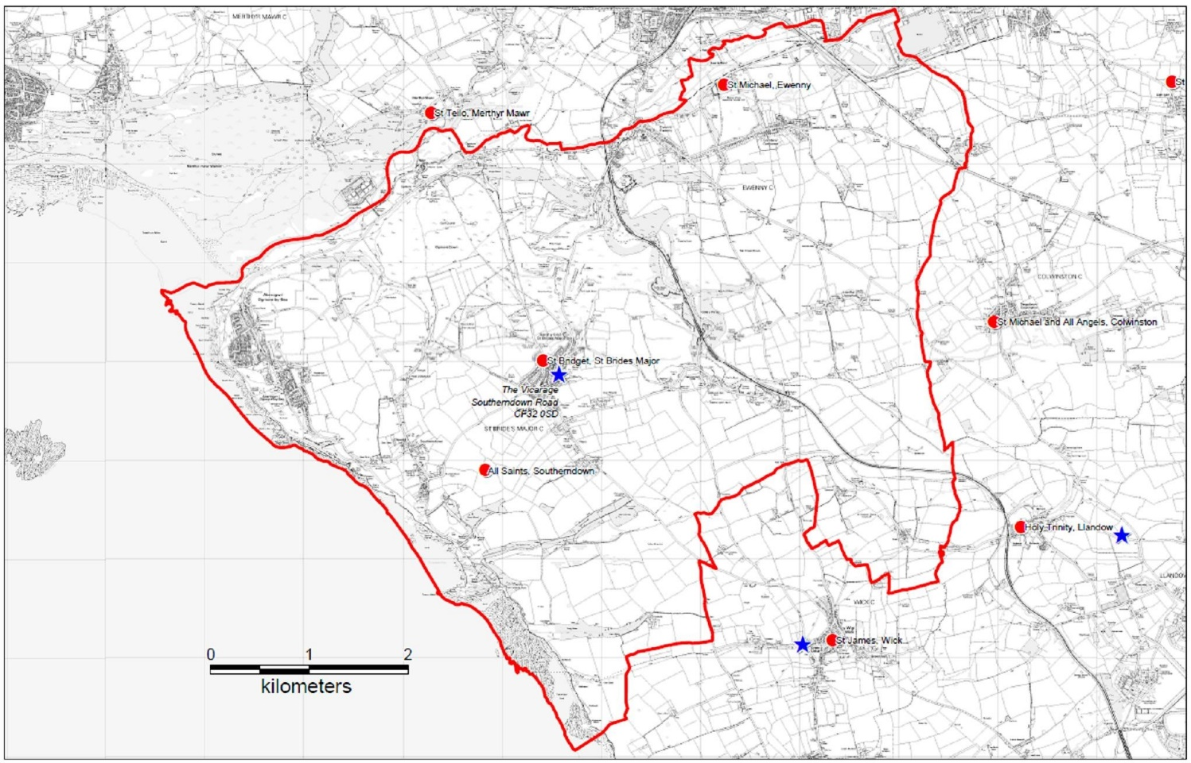

*The communities of Ewenny and St Brides Major*