
St Brides Major C/W Primary School Curriculum News
Topic: Beach Nursery Summer 2025
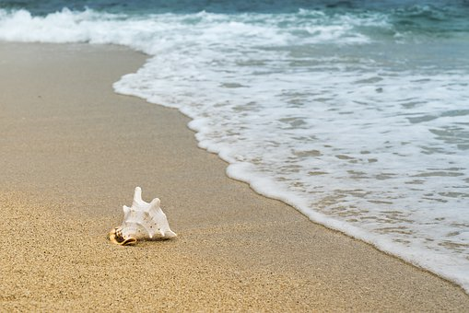

Project Overview

This project has a Science and technology/Humanities focus and enables children to explore plants, animals and materials found on the seashore.
In this project children will learn about:
• Plants and animals that live on the seashore
• Man-made and natural features of the seashore
• Names of different coastal towns and beach resorts in Wales
• Keeping safe at the seashore, including water hazards
• Properties of natural materials found at the seashore including sand, water, rock, shingle and driftwood
• Creating temporary art using natural materials
• Traditions of the seaside
• Recording ideas, feelings and experiences through drawing, mark making and emergent writing
• Using voices and bodies to respond imaginatively to sounds and music
• The effects of pollution on the natural habitat
• The Welsh language using words and phrases across a range of experiences in the indoor and outdoor environment.

We will be learning all about the beach, sea creatures, staying safe by the sea and in the sun and having hands on experience when we go on a trip to Rest Bay, Porthcawl and learn all about the beach with the Beach Academy.
Language, Literacy and Communication.
Your child will be given the opportunity to:
- Explore a ‘Beach-Combers Basket’ that contains a range of found items from a local beach.
- Describe an animal that lives on the seashore, using pictures and annotation on Seesaw.
- Reading stories about the beach, seaside eg Sharing a Shell, The Whale and the Snail, The Rainbow Fish to name a few.
- Take part in songs, rhymes and poems about the seashore. Sing and say rhymes, poems and songs together on a daily basis.
- Think of words that they might use to describe the sights, sounds and smells of the seashore using items such as seaweed, sea water, shells, crab shells, pebbles, and so on, to rattle, shake, smell and touch.
- Listen to and talk about the rules of the ‘Seashore Code’. Children will be provided with opportunities to respond to what they have found out through drawing, mark making, emergent writing and role-play.
- Create a rock pool in a sand tray, using rocks, sand, pebbles, shells and toy sea creatures.

We will be introducing the Read, Write inc sounds in preparation for starting Reception in September (morning Nursery only). Children will be able to mark make in various different mediums eg sand, shaving foam, water bottles!!!

International Languages - We will be learning French this term, using greetings and learning to count and colours. Pupils will build on their knowledge and understanding of communication in the world around us.
Welsh - We will be learning about the culture of Wales and its language. The children will be using incidental Welsh daily such as numbers, colours, rhymes, songs and greetings and also learning a variety of topic related vocabulary relating to the beach.
The children will learn how to reply to Sut wyt ti? Pwy wyt ti?, and answering ydw and nac dydw to Wyt ti’n hapus etc

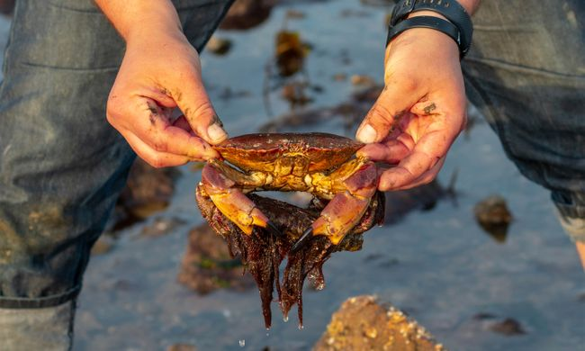
Religious Education
This term we will be continuing to teaching RE using a scheme called
Understanding Christianity.
Your children will be discovering the world of Christianity through daily worship (assemblies) and through play-based activities within their setting.

This term our Gospel Values are Wisdom and Service, and we will be exploring stories from the Bible that demonstrate this.

Your children will be discovering the world of Christianity through daily worship and through play based activities within their setting. This term in Nursery we will be learning all about The Church, particularly St Bridget’s Church, its features and purposes.
Maths and Numeacy
We will be counting to 20 and learning to recognise numbers 1-20. We will learning to count down from 10.
We will explore money and be using it as part of their Beach café and Ice Cream Parlour role play activities.
The children will be sorting and comparing objects of different sizes and 2D shapes.
Through topical activities your children will also be learning about ordinal numbers, time and positional language.
We will be continuing to learn the days of the week.

Health and Wellbeing
There will be an emphasis on caring - for each other, our immediate environment and the world.
We will be planting and become aware that we need to care for them and also the world that we live in.
As part of the Butterfly conservation, we will be learning about the Fritillary Butterfly which is special to this area and creating our own butterflies.
Our role play areas this term will consist of a beach shop/café and Ice Cream parlour. The children will develop their ability to share with their peers further, take turns and they will also develop their friendships whilst working in their learning environment. We will also continue the Jigsaw PHSE scheme.
Your children will be taking part in games and gymnastic sessions.
PE with Mr Nurton every Friday (morning Nursery only).
PE Tuesday (afternoon Nursery).
Your children will take part in athletic type activities during the second half term, improving on their throwing and running skills in readiness for sports day.
The children will develop hand eye co-ordination using small equipment. Other physical development activities will be developed through topical play both indoors and out, threading, riding bikes, building models and dens and construction such as Lego etc.
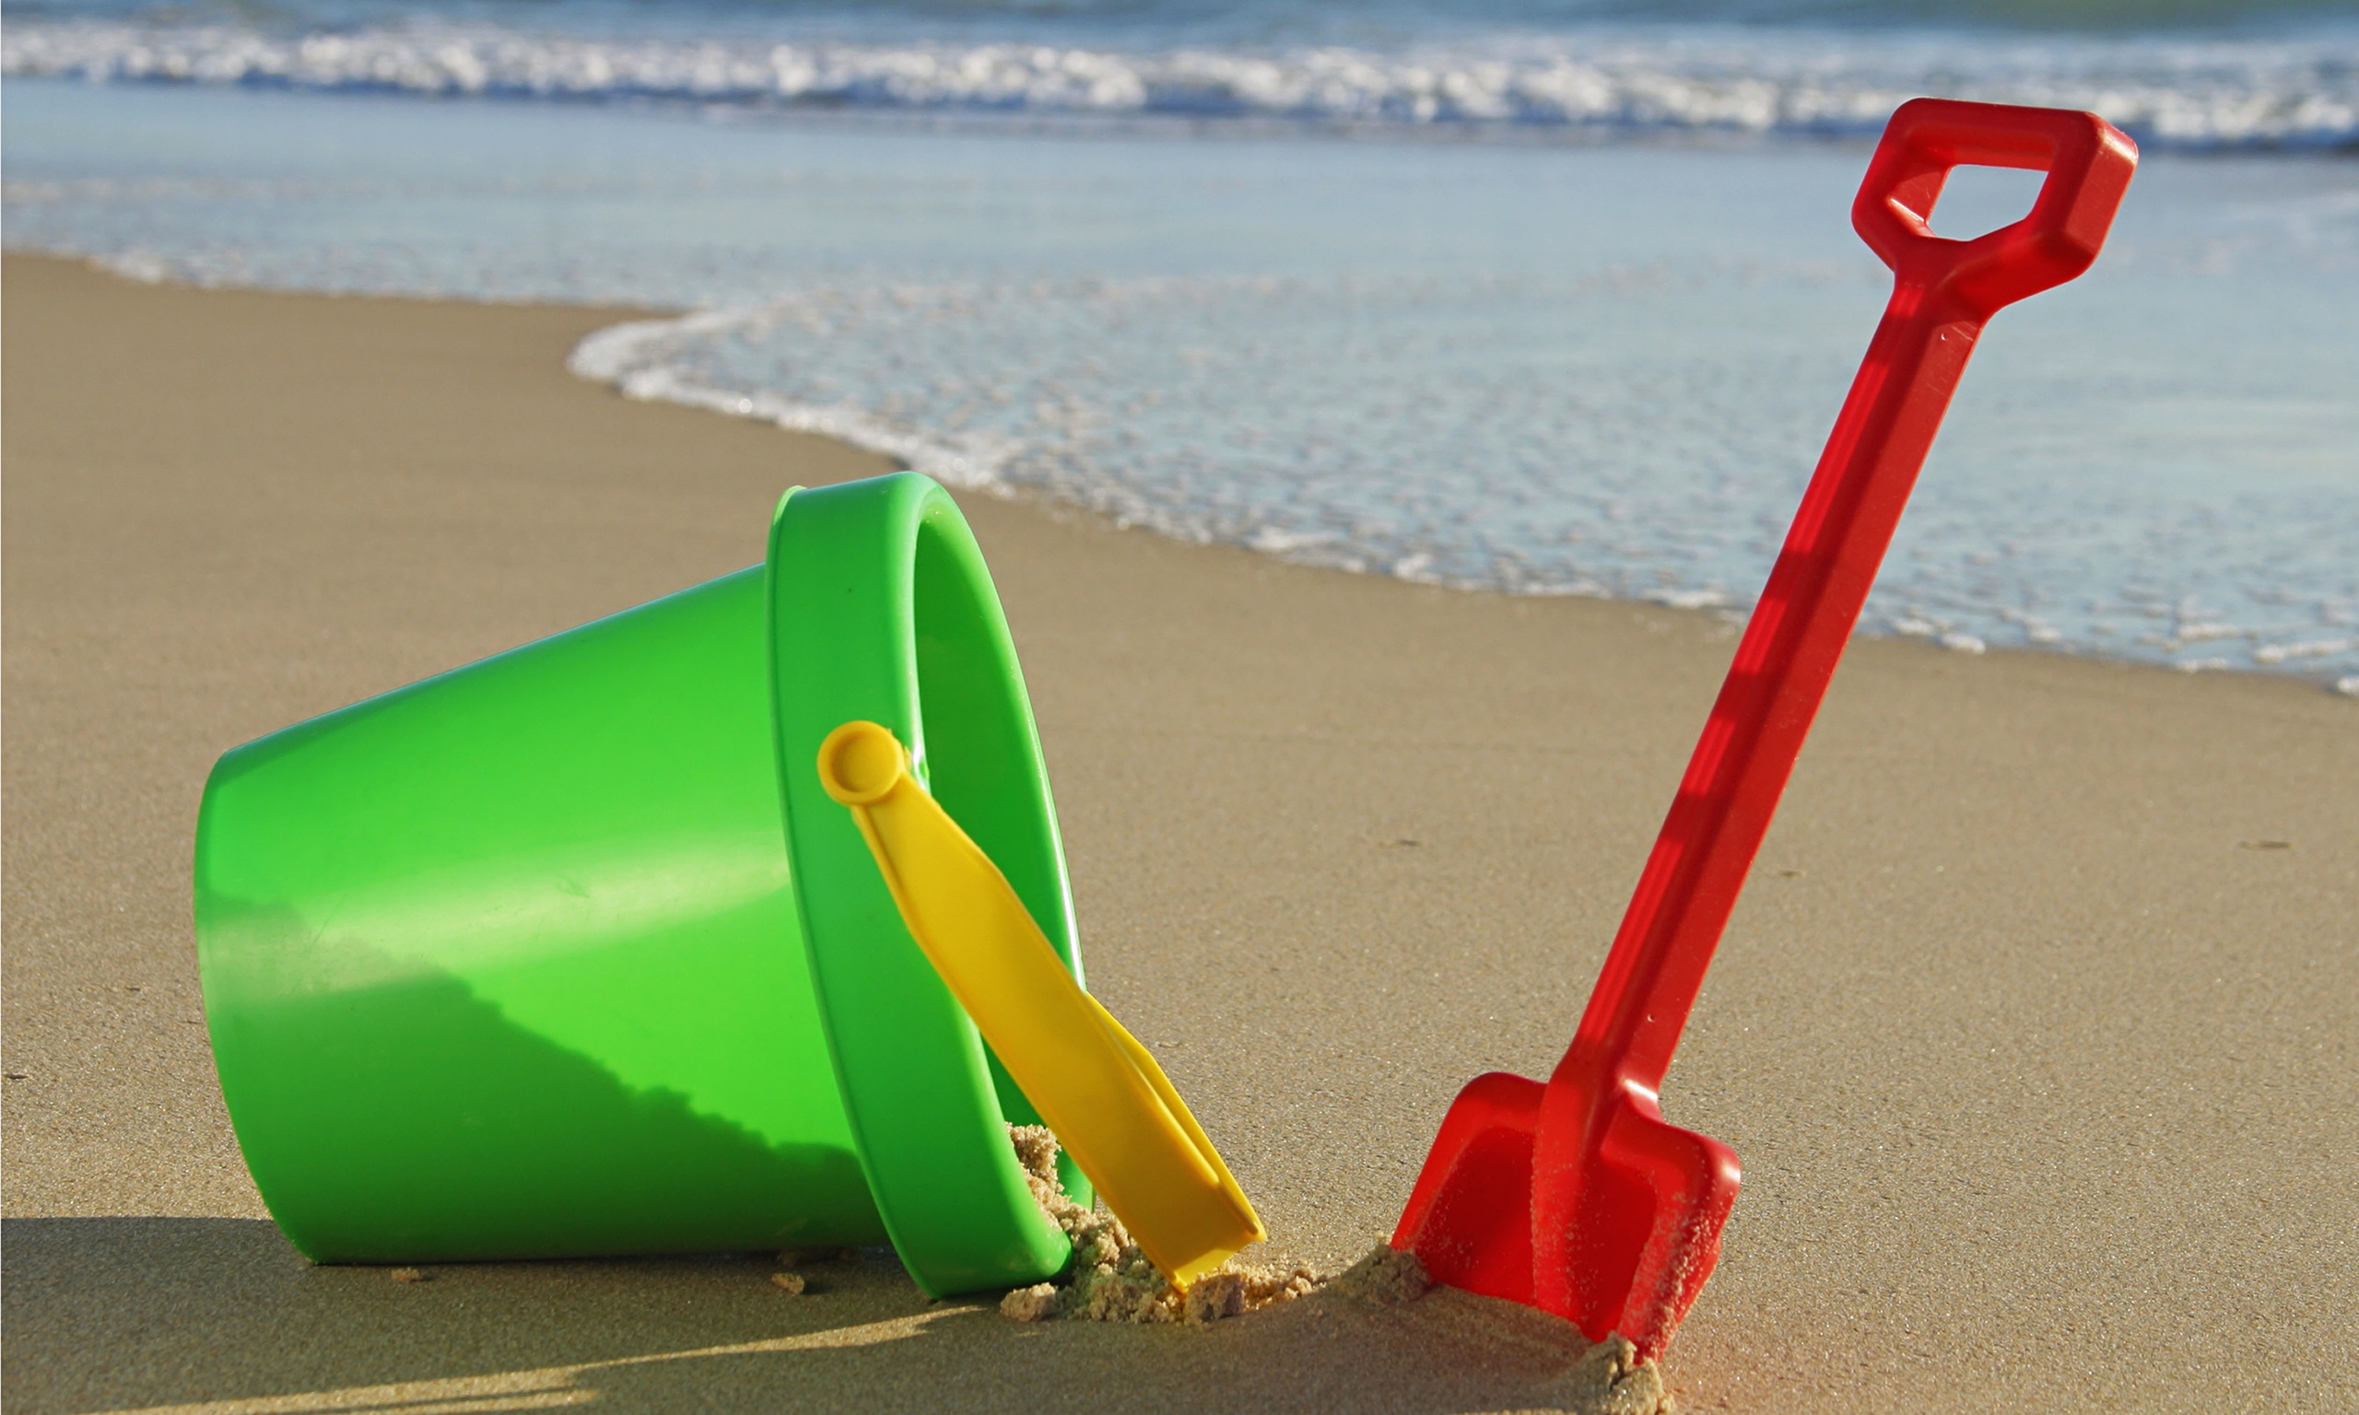

Humanities
The children will have the opportunity to:
We will observe samples of seaweed and other beach materials using the magnifying glasses.
We will be finding out about creatures that grip the rocks including sea anemone, starfish, limpets, and sea urchins. We will use information books, discussion, first hand experiences and the Internet to find out information about them.
We will explore the properties of wet and dry sand using sand tools.
We will find out about a seashore and coastal resorts in Wales as a collaboration project with Year 3.

We will look at books and the internet which show features of the varying habitats and talk about other beach resorts in the world and look at ways in which they are different to local seashore habitats.

