CALCULATOR PAPER
1. Here are five digit cards.
Use each card once to complete the statements below.

2. The sum of two numbers is 100
Write in the missing digits.

3. Each missing digit in this sum is a 9 or a 1
Write in the missing digits.
+ + = 201

4. Each missing digit in these calculations is 2, 5 or 7
Write in the missing digits.
You may use each digit more than once.
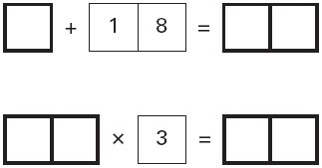

5. 17 multiplied by itself gives a 3-digit answer.
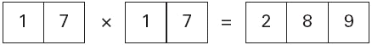
What is the smallest 2-digit number that can be multiplied by itself to give a 4-digit answer?


6. Here are five digit cards.
Use all five digit cards to make this correct.
7. Use the digits 2, 3 and 4 once to make the multiplication which has the greatest product.
×

8. Here are five number cards.
A and B stand for two different whole numbers.
The sum of all the numbers on all five cards is 30
What could be the values of A and B?

9. Here are five digit cards.
Use all five digit cards once to make this sum correct.

10. Write what the three missing digits could be in this calculation.

11. Here are some number cards.
Use five of the number cards to make this correct.

12. Write two numbers, each greater than 100, to complete this subtraction.

13. Write in the four missing digits.
Put one digit in each box.
+ = 198

14. Write the number that is nearest to 5000 which uses all the digits 4, 5, 6 and 7.

