1. In this diagram the rule is

‘double the number in the square
and add the number in the triangle
to make the number in the circle’.

Use the same rule to write in the missing numbers below.

2. Ben thinks of a number.

He adds half of the number to a quarter of the number.
The result is 60
What was the number Ben first thought of?

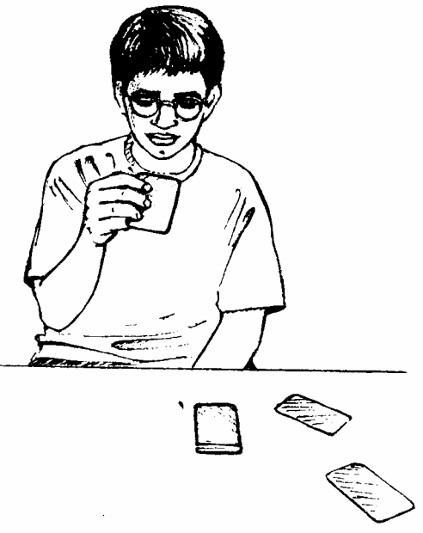
3. Rob has some number cards.

He holds up a card.
He says,
‘If I multiply the number on this card by 5, the answer is 35’.
What is the number on the card?
……………………………..

He holds up a different card.
He says,
‘If I divide the number on this card by 6, the answer is 4’.
What is the number on the card?
………………………….

4. Leon and Sara each started with different numbers.
Leon and Sara both get the same answer.
What numbers could they have started with?
Leon Sara

