Inverse operation problems with a calculator
1. Emily chooses two numbers.

She adds the two numbers together and divides the result by 2
Her answer is 44
One of Emily’s numbers is 12
What is Emily’s other number?


2. Josh thinks of a number.

He adds 4
He multiplies his result by 3
Then he takes away 9
His final answer is 90
What number did Josh start with?
…………………………………..

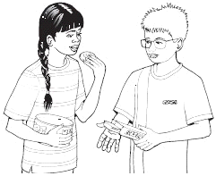
3. Sapna and Robbie have some biscuits.
Altogether they have 14 biscuits.
Sapna has 2 more biscuits than Robbie.
How many biscuits do Sapna and Robbie each have?
Sapna Robbie

4. Jemma thinks of a number.
She says,
'Add 3 to my number and then
multiply the result by 5
The answer is 35'
What is Jemma's number?
……………………………….

Riaz thinks of a number.
He says,
'Halve my number and then add 17
The answer is 23'
What is Riaz's number?
………………………………….

5. n stands for a number.
Complete this table of values.
n | 5 n – 2
20 | 38

